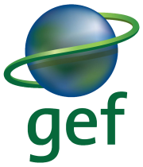
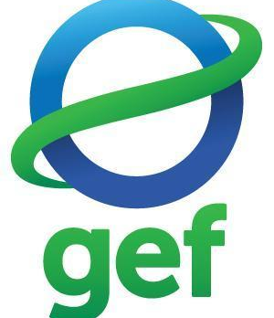

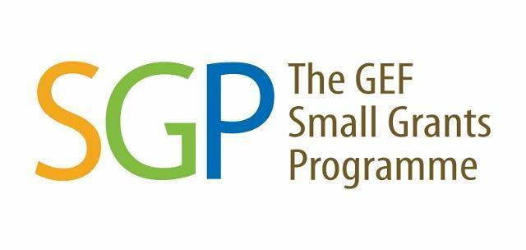


TERM OF REFERENCES FOR

THE SMALL GRANTS PROGRAMME (SGP)

Call for Concept Proposals

Location:
Middle and Upper Baram, Sarawak

I. Background

The Small Grants Programme (SGP) provides grants to NGOs, CBOs and local communities for community level conservation, restoration and sustainable livelihood interventions. The seventh Operational Phase (OP7) of the GEF Small Grants Programme (SGP) in Malaysia aims to build upon the long-standing achievements of SGP in the country, specifically involving strengthening civil society organisations and improving socioeconomic conditions for local communities through the implementation of participatory conservation, restoration, and climate change mitigation interventions.

Starting in OP7, Malaysia has been included in the Upgraded Country Programme (UCP) of the SGP. With the aim of achieving impacts at scale and ensuring the sustainability of results achieved, the programme level strategy of the UCP is based on a landscape approach, following the UNDP approach of community-driven planning and management of socio-ecological production landscapes and seascapes. The three selected landscapes (Crocker Range Biosphere Reserve in Sabah; the Middle and Upper Baram River Basin in Sarawak; and the Klang Valley in Peninsular Malaysia) cover expansive and complex rural and urban geographies.

In OP7, the project in Middle and Upper Baram, Sarawak aims to foster collaboration among regional community organisations in the landscape. This collaboration aims to promote socio-ecological resilience, benefitting the global environment and facilitating sustainable development. In addition, the project promotes activities related to forest conservation within the targeted landscapes, community livelihood improvement, community participatory in biodiversity conservation and restoration, landscapes undergoing improved practices, policy reforms for the sustainable resource management and climate mitigation projects.

The project aims to reach an estimated 3,150 direct beneficiaries, 50% of whom are women, the project will facilitate community-driven interventions that generate global environmental benefits, including bringing an estimated 8,000 ha of landscapes under improved practices, 3,000 ha of landscapes under sustainable land management in production systems, restoring 200 ha degraded agricultural lands and 100 ha forest lands, as well as achieving 8,000 ha of landscapes that meets national or international third-party certification, from all the projects executed under the SGP within the Baram landscape.

The Middle and Upper Baram landscape strategy is developed by the WormingUp (Fly Technology Agriculture) team with close consultation with stakeholders. The landscape strategies developed will provide guidance to the selection and prioritisation of these actions to be addressed by community-level projects. The project’s landscape approach provides an ecological and socio-economic framework for participatory biodiversity conservation and restoration initiatives, sustainable agroecological practices, and restoration of degraded land and forest ecosystems. Community level activities are also designed to strengthen capacities for community-level renewable energy (RE) and energy efficient (EE) solutions. Community grants will enable development of proven technologies such as micro- and pico- hydroelectric, energy efficient lighting systems, effective cook stove etc. as well as the broader adoption of successful applications. All the applicants of this call should refer to the Middle and Upper Baram Landscape Strategy and ensure the proposed activities in the proposal aligns with the strategy.

II. Project Objective

To enable community organisations to take collective action for adaptive landscape management in building socio-ecological resilience in the Middle and Upper Baram, Sarawak for global environmental benefits and sustainable development.

III. Scope of the Assignment and Indicative Activities

Competent organisations are encouraged to submit an application on the basis of the Call for Concept Proposals below. The proposals will be reviewed and approved by the SGP National Steering Committee (NSC).

All project activities must also be in line with the landscape strategy developed by the landscape strategy grantee. Note that the landscape strategy will be updated periodically as the situation on the ground evolves, please check for the latest version with SGP Secretariat. In the process of developing the project’s proposal, it is crucial to consider the following focuses (either one or more than one) in the overall project’s strategy.

The Middle and Upper Baram Strategy seeks to reach this objective by pursuing the following five target outcomes by 2026:

- 300 hectares of land restored;
- 19,000 hectares of landscapes under improved practices;
- Greenhouse gas emissions mitigated equivalent to 76,625 tonnes of carbon dioxide; and
- 3,150 individuals directly benefiting

This will be accomplished and aided by SGP grant-funded projects within the Middle and Upper Baram, led by NGOs, CBOs, and local communities.

The potential projects include the following (but not limited to):

Biodiversity and Land Degradation:

- Improved management of forest ecosystems to benefit biodiversity and promoting nature-based livelihood options (incl. ecotourism) for local communities;
- Strengthened community forest management, building capacities for establishment of a Baram Eco-Community Forest, including community mapping;
- Participatory restoration of degraded forest land as part of improved landscape management / avoided deforestation / degradation;
- Empowering local community in developing sustainable agriculture for livelihoods and enhanced land management and participatory restoration of degraded agriculture ecosystems;
- Through dialogue with logging concession holders and government stakeholders, enhance social and economic well-being of local communities through sustainable management and utilisation of forest resources;
- Documentation of traditional knowledge related to biodiversity (e.g., traditional knowledge recordings, resource classification systems, etc);
- Climate resilience agriculture such as agroforestry, syntropic and regenerative agriculture;
- Marketing and social enterprise for livelihood improvement.

Climate Change Mitigation:

- Fuel-efficient cook stoves
- Micro- and pico- hydroelectric generators for off-grid communities
- Solar PV for off-grid communities
- Biogas (at community level) for cooking
- Gasification system & turbine generator producing both power and biochar.

IV. Eligible Organisations & Funding Criteria

- Locally registered Non-Government Organisations (NGOs) / Community-Based Organisations (CBOs) / Civil Society Organisations (CSOs), with an existing copy of the certificate of registration.
- Local registered bank account of the organisation.
- Unregistered CBOs or CBOs without bank accounts, please contact SGP Secretariat for the potential arrangement of an intermediary contract with established NGOs.
- The organisation demonstrates strong organisational capacity to implement SGP grant projects and meet SGP requirements.
- Languages used in the documentation: BOTH Malay and English are accepted. Applications must be submitted using the provided template (Proposal Concept Proposal Template). All applications using other templates will not be considered.

V. Grant Amount

The maximum amount per grant project will be limited to US$ 50,000. The applicant should request the grant based on the estimated expenditures required to conduct proposed activities, NOT the maximum grant available. Applicants are required to submit estimate budgetary in the concept proposal template.

VI. Project Duration

All projects must be undertaken and completed by December 2025. The funds will be distributed on a milestone completion basis.

VII. Relevant Documents

Applications MUST be submitted using the provided templates.

1. Concept Proposal Template: English / Bahasa Malaysia

VIII. Proposal Assessment Criteria

Grant applications will be reviewed by the NSC members and deliberated during the NSC Meeting. The following criteria are used to assess all applications:

- Relevance of the Project Activities: Must be consistent with the SGP OP-7 Project Document and Landscape Strategy.
- Design of the Proposed Project: Consists of problem statement, justification, objectives, project activities, measurable outputs and results/outcomes, stakeholder and community engagement plan, knowledge management plan, project implementation timeframe, project risks, and monitoring & evaluation plan.
- Project Implementation and Management Capacity: Must be able to demonstrate strong organisational capacity to implement SGP grant projects and meet SGP requirements.
- Co-financing: Applicants must provide any co-financing commitments.
- Sustainability of the Project: Must have tangible impacts, potential for upscaling and/or replication, sustainable financial viability, positive influence on policy and environmental impact.
- Budget and cost-effectiveness of the action

IX. Grant Application Process

Please refer to the grant flowchart below for an overview of our grant process:

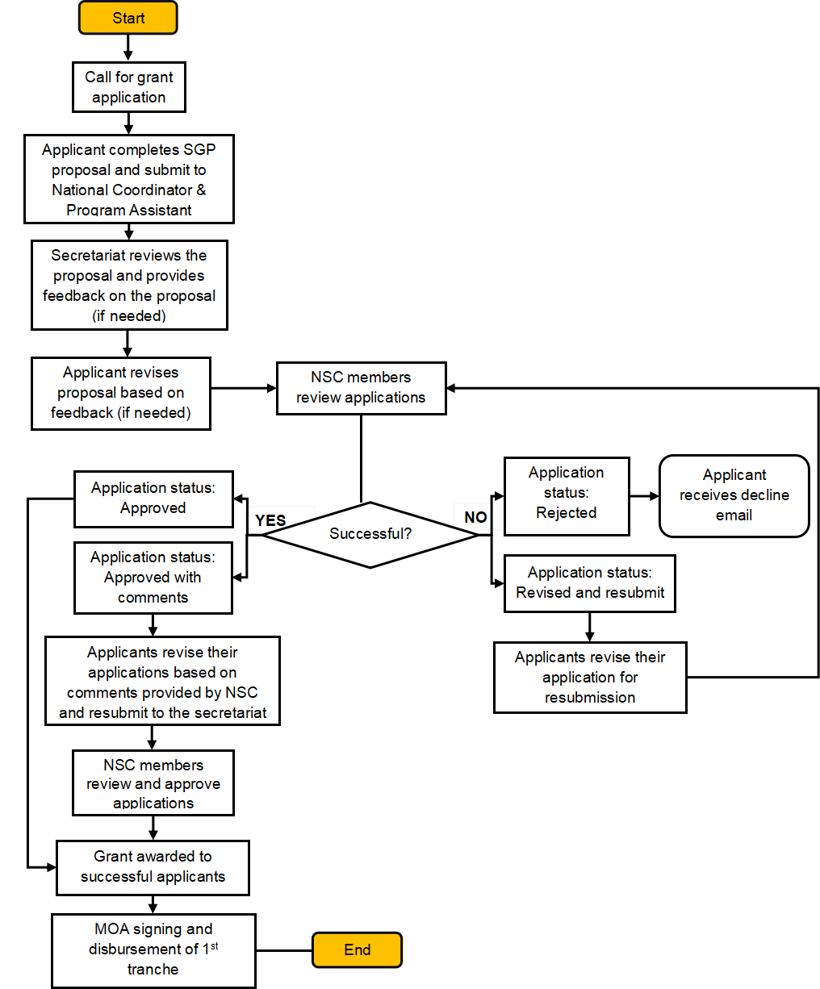

For concept proposal submission and more information, please contact:

Lee Shin Shin (Ms)
National Coordinator
GEF Small Grants Programme - Malaysia
Tel: +603 8689 6055
Email: shin.shin.lee@undp.org

Nurul Fitrah Mohd Ariffin Marican (Ms)
Programme Assistant
Email: nurul.fitrah.mohd.ariffin.marican@undp.org

